**主题：新加坡为什么要大力发展公共交通？**

**Why is Singapore Strongly Developing Public Transport?**

第一页 新加坡交通系统的成功转型与全球领先地位**The Successful Transformation of Singapore’s Transportation System and Its Global Leadership**

新加坡被称为世界上最宜居的城市，极度繁华，还非常宜居。其内在的支撑要素之一就是保持了城市交通的便利和通畅，实现了基本无堵的目标。Singapore is known as one of the most livable cities in the world. It’s extremely prosperous and yet very livable, largely due to its efficient and smooth transportation system that has practically eliminated traffic congestion.

根据麦肯锡公司调查结果，全世界交通系统最发达的城市就是新加坡。在新加坡，市中心平均车速为**每小时28公里**，快速路平均车速为**每小时60公里**，**超过95%的快速路和主干道在高峰期没有拥堵。**According to a survey by McKinsey, Singapore has the most advanced transportation system in the world. In Singapore, the average speed in the city center is 28 kilometers per hour, and on expressways, it is 60 kilometers per hour. Over 95% of expressways and main roads are free from congestion during peak hours.

而上世纪七八十年代，新加坡的市区交通拥堵严重，马路也常常变成公共停车场。新加坡如何在30多年的时间里实现了这样的蜕变？有哪些良好的治理机制与策略？ However, in the 1970s and 1980s, traffic congestion in Singapore's urban areas was severe, with roads often turning into public parking lots. How did Singapore achieve such a transformation in just over 30 years? What effective governance mechanisms and strategies were used?

第二页 人口增长与轨道交通发展的历史基础Population Growth and the Historical Basis for Rail Transit Development

新加坡的城市活力吸引了大量的人口，不断增长的人口也对新加坡的交通系统提出了新的需求。Singapore's urban vitality has attracted a large population, and the increasing population has brought new demands on Singapore’s transportation system.

表一：- 引入人口增长图表，以显示人口增长与对更高效、更可持续的交通选择的需求之间的关系。提供了发展新加坡铁路系统的论据。*Chart 1*: A population growth chart is introduced to show the relationship between population growth and the need for more efficient, sustainable transport options. This provides an argument for the development of Singapore's rail system.

早在 1963 年，联合国开发计划署的一份关于未来城市发展战略的报告就建议新加坡投资单轨列车或地铁，并指出这些选择最适合城市景观，也最具成本效益。As early as 1963, a report from the United Nations Development Program (UNDP) on future urban development strategies suggested that Singapore should invest in monorail or subway systems, pointing out that these options were most suitable for the city landscape and cost-effective.

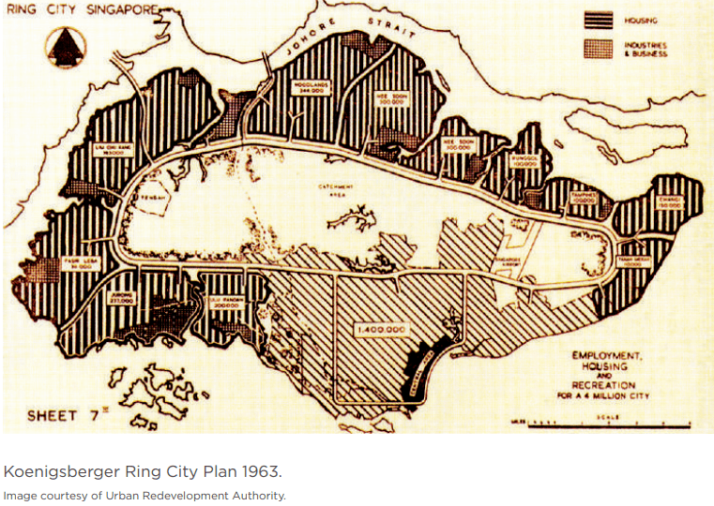

1963 年联合国开发计划署顾问提出的新加坡城市交通网络大纲

在1970 年代，半数新加坡人驾车出行，产生了严重的交通拥堵，并且停车位占据了大面积的公共空间。1971年，市区重建局（URA）提出第一个概念计划，奠定基础今天新加坡城市的整个空间结构。计划中，新加坡的自然保护区和集水区保存在岛的中心，周围环绕着一圈独立的卫星新城开发项目，呈“星群式”的城市格局，而轨道交通将作为“血管”。In the 1970s, half of Singapore’s population traveled by car, resulting in severe traffic jams, and parking spaces took up large amounts of public space. In 1971, the Urban Redevelopment Authority (URA) proposed the first concept plan, laying the foundation for today’s entire spatial structure of Singapore. The plan preserved nature reserves and water catchment areas in the center of the island, surrounded by independent satellite town developments in a ‘constellation’ pattern, with rail transit serving as the ‘veins’ of the system.

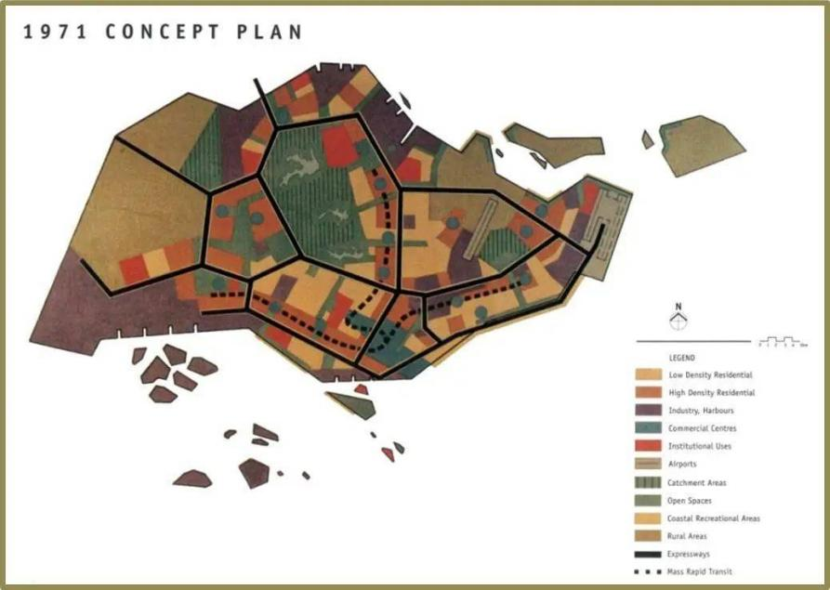

新加坡 1971 年概念计划，来源：市建局

1991 年的概念计划则明确了新加坡的整个城市系统必须以公共交通为第一组织原则，此后重新定义了新加坡的城市面貌。土地利用与交通规划相结合，同时将商业活动从城市中心区分散开来。权力下放将有助于缓解市中心的拥堵，公共交通将在城市发展中发挥核心作用。In 1991, a new concept plan clearly stated that public transport must become the primary organizational principle for Singapore’s entire urban system, which has since redefined the city's landscape. The integration of land use and transport planning, along with the decentralization of commercial activities from the city center, was aimed at alleviating congestion. Public transport would play a core role in urban development.

第三页 轨道交通基础设施的持续扩展与现代化Continuous Expansion and Modernization of Rail Infrastructure

到90年代末，2000年初，新加坡的城市交通基础设施已经发展到多方面，以至于新加坡被视为“交通大都市”的开创性例子：一个特别有利于可持续公共交通模式的城市。到2023年，新加坡的城市交通基础设施愈发完备。By the late 1990s and early 2000s, Singapore’s urban transport infrastructure had developed to the point that the city became a pioneering example of a ‘transport metropolis’—a city particularly conducive to sustainable public transport models. By 2023, Singapore's urban transport infrastructure had become even more complete.

表2（视频）：新加坡铁路网络从 *1990 年到 2023 年的增长情况。突出显示铁路里程数的增加*，并展示图表以直观地了解扩张情况。*(Video)*: The growth of Singapore's rail network from 1990 to 2023. Highlights include the increase in rail mileage and a chart visually showing the expansion. ????????????

表3：新加坡铁路网络从 *1990 年到 2023 年的增长情况。Chart *3*: Growth of Singapore's rail network from 1990 to 2023.

第四页 “拥车证”政策及公共交通需求的不断增长The Certificate of Entitlement (COE) Policy and the Growing Demand for Public Transport

随着公共交通里程的不断增长，也有越来越多的居民享受到公共交通带来的好处。As public transport mileage continues to grow, more and more residents benefit from the conveniences brought by public transportation.

表4：新加坡公共出行人数表。Chart *4*: Singapore public transport usage statistics.

于此同时，在1990年，为了配合可持续公共交通模式，新加坡政府还出台了独特的“拥车证”政策。按照这一规定，个人在购买新车时，必须首先向政府提出申请，投标购买一张有效期为10年的“拥车证”。10年期满后，驾车者无论是继续用车还是另购新车，都必须支付另外一笔费用。在一段时间内，这一政策有效地限制了新加坡私家车的数量，保证了道路的畅通。In 1990, to support a sustainable public transport model, the Singapore government introduced the unique Certificate of Entitlement (COE) policy. According to this policy, individuals must apply to the government and bid for a COE, which is valid for 10 years, before purchasing a new car. After the 10-year period, drivers must pay an additional fee whether they continue to use their car or purchase a new one. For a time, this policy effectively limited the number of private cars in Singapore, ensuring smooth traffic flow.

然而，最近十年的统计数据表明，即使“拥车证”政策也无法阻挡民众购车的决心，再多的公交及出租车也无法满足民众的出行需求，越来越多的私家车开始行驶在道路上。However, recent data shows that even the COE policy could not completely curb the public's desire to buy cars. Despite more buses and taxis, private car ownership has continued to rise, with more cars on the roads.

表5新加坡公共交通还需要进一步的建设以满足居民的需求。Chart *5*: Additional construction of public transport is necessary to meet residents' growing needs.

第五页 新加坡公共交通面临的挑战与未来发展建议Challenges Facing Singapore’s Public Transport and Future Development Recommendations

挑战不止于此，新加坡现有的公共交通依然存在问题，需要解决。Challenges still exist, and Singapore's current public transport system has issues that need to be addressed.

2024年，新加坡的环线地铁刚在9月17日发生技术故障，没想到才过了没多久，东西线地铁服务9月25日也发生了故障。造成这次故障的原因是一故障列车在返回维修站时造成轨道受损，导致从波娜维斯达到裕廊东的地铁服务中断了6天，这也是新加坡史上地铁服务中断时间最长的一次事故。据估计，有超过80万人受这次地铁故障的影响。In 2024, the Circle Line experienced a technical failure on September 17, followed by another incident on the East-West Line on September 25. The latter was caused by a faulty train damaging the tracks as it returned to the maintenance depot, leading to a six-day disruption of train services from Buona Vista to Jurong East, marking the longest service interruption in Singapore’s MRT history. It is estimated that more than 800,000 people were affected by this disruption.

Chart 6：Service-delay.html.

该如何去解决？我们提出了以下几点建议：

1. 研发新技术、新形势的交通出行解决方案，如低空出行、个人飞行器。
2. 加大力度建设交通出行网络，覆盖全城所有区域。
3. 加强对现有基础设施的维护，以最大限度地减少中断并提高整体运输效率。

How should these issues be resolved? We propose the following recommendations:

1. Research and develop new transportation solutions, such as low-altitude travel and personal flying vehicles.
2. Increase efforts to expand the transportation network, covering all areas of the city.
3. Strengthen the maintenance of existing infrastructure to minimize disruptions and improve overall transport efficiency.

~~表7（视情况增加）：这里加入对新加坡公共交通的建议或者相应图表。可以探讨新技术、维护协议或替代解决方案，以最大限度地减少中断并提高整体运输效率。~~